Loops (For, While, Do-While)

Theory Assignment
Question 1: Explain the different types of loops in JavaScript (for, while, do-while). Provide a basic example of each.
Ans: Loops in JavaScript allow a block of code to run multiple times as long as a given condition is satisfied. They help reduce repetition and make programs more efficient and organized.
- Loops continue running until the condition becomes false.
- They are useful for iterating over arrays, strings, and ranges of values.
In JavaScript, there are three types of Loops :
1. for Loop
The for loop repeats a block of code a specific number of times. It contains initialization, condition, and increment/decrement in one line.
Syntax
for (initialization; condition; increment/decrement) { // Code to execute}
Example: The below JavaScript program for loop runs from i = 1 to i = 3, incrementing i by 1 each time, and prints "Count:" followed by the current value of i.
for (let i = 1; i <= 3; i++) {
console.log("Count:", i);
}
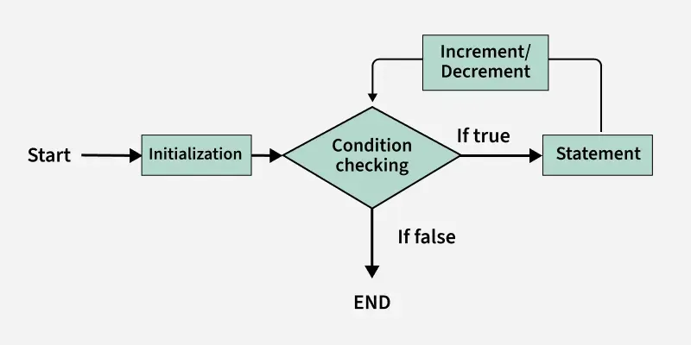The image below demonstrates the flow chart of a for loop:
Initialization condition: Here, we initialize the variable in use. It marks the start of a for loop. An already declared variable can be used or a variable can be declared, local to loop only.
- Testing Condition: It is used for testing the exit condition for a loop. It must return a boolean value. It is also an Entry Control Loop as the condition is checked prior to the execution of the loop statements.
- Statement execution: Once the condition is evaluated to true, the statements in the loop body are executed.
- Increment/ Decrement: It is used for updating the variable for next iteration.
- Loop termination:When the condition becomes false, the loop terminates marking the end of its life cycle.
1.1 for in loop
The for-in loop iterates over the enumerable keys of an object.
Syntax:
for (let key in object) {
// code to be executed
}
Example: The below JavaScript program for-in loop iterates over the keys of the person object and prints each key with its corresponding value.
const person = { name: "Alice", age: 22, city: "Delhi" };
​
for (let key in person) {
console.log(key, ":", person[key]);
}
1.2 For each loop
The forEach loop executes a provided function once for each element in an array.
Syntax:
array.forEach(function(element, index, array) {
// code to execute
});
Example: The below JavaScript program forEach loop executes a function for each element in the numbers array, printing each number.
const numbers = [10, 20, 30];
​
numbers.forEach(function(num) {
console.log(num);
});
2. while Loop
The while loop executes as long as the condition is true. It can be thought of as a repeating if statement.
Syntax
while (condition) {
// Code to execute
}
Example: The below JavaScript program while loop prints "Number:" followed by i repeatedly while i is less than 3, incrementing i by 1 each time.
let i = 0;
while (i < 3) {
console.log("Number:", i);
i++;
}
The image below demonstrates the flow chart of a while loop:
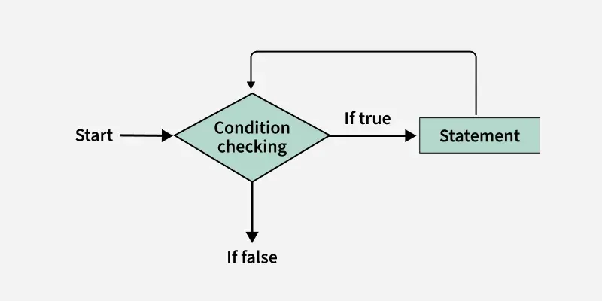
While loop starts with the checking of Boolean condition. If it evaluated to true, then the loop body statements are executed otherwise first statement following the loop is executed. For this reason it is also called Entry control loop
- Once the condition is evaluated to true, the statements in the loop body are executed. Normally the statements contain an update value for the variable being processed for the next iteration.
- When the condition becomes false, the loop terminates which marks the end of its life cycle.

3.do-while Loop
The do-while loop is similar to while loop except it executes the code block at least once before checking the condition.
Syntax
do {
// Code to execute
} while (condition);
Example: The below JavaScript program do-while loop prints "Iteration:" followed by i, increments i by 1, and repeats the process while i is less than 3, ensuring the block runs at least once.
let i = 0;
do {
console.log("Iteration:", i);
i++;
} while (i < 3);
The image below demonstrates the flow chart of a do-while loop:
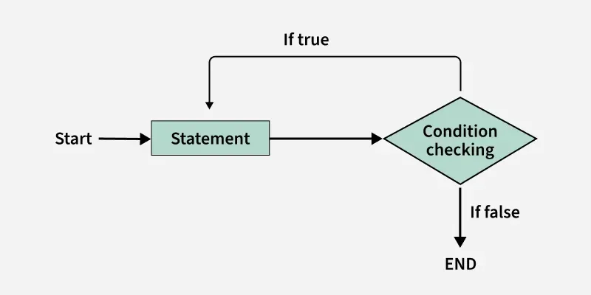do while loop starts with the execution of the statement. There is no checking of any condition for the first time.
- After the execution of the statements, and update of the variable value, the condition is checked for true or false value. If it is evaluated to true, next iteration of loop starts.
- When the condition becomes false, the loop terminates which marks the end of its life cycle.
- It is important to note that the do-while loop will execute its statements at least once before any condition is checked, and therefore is an example of exit control loop.

Question 2: What is the difference between a while loop and a do-while loop?
Ans: For Loop, While Loop, and Do-While Loop are different loops in programming. A For loop is used when the number of iterations is known. A While loop runs as long as a condition is true. A Do-While loop runs at least once and then continues if a condition is true.

For Loop in Programming:
- The for loop is used when you know in advance how many times you want to execute the block of code.
- It iterates over a sequence (e.g., a list, tuple, string, or range) and executes the block of code for each item in the sequence.
- The loop variable (variable) takes the value of each item in the sequence during each iteration.

For Loop Syntax:
for (initialization; condition; increment/decrement) {
// Code to be executed repeatedly
}

Examples:
#include <iostream>
using namespace std;

int main()
{
for (int i = 0; i < 5; i++)
cout << i << "\n";
return 0;
}
Output
0
1
2
3
4

While Loop in Programming:
- The while loop is used when you don’t know in advance how many times you want to execute the block of code. It continues to execute as long as the specified condition is true.
- It’s important to make sure that the condition eventually becomes false; otherwise, the loop will run indefinitely, resulting in an infinite loop.

While Loop Syntax:
The syntax of a while loop is straightforward:
while (condition){
# Code to be executed while the condition is true
}

Examples:
#include <iostream>
using namespace std;
​
int main()
{
int count = 0;
while (count < 5) {
cout << count << "\n";
count += 1;
}
cout << endl;
return 0;
}
Output
0
1
2
3
4

Do-While Loop in Programming:
- The do-while loop is similar to the while loop, but with one key difference: it guarantees that the block of code will execute at least once before checking the condition.
- This makes it useful when you want to ensure that a certain task is performed before evaluating a condition for continuation.
- The loop continues to execute as long as the specified condition is true after the first execution. It's crucial to ensure that the condition eventually becomes false to prevent the loop from running indefinitely, leading to an infinite loop.

Syntax of do…while Loop:
do {
// body of do-while loop
} while (condition);

Examples:
#include <iostream>
using namespace std;
​
int main()
{
int count = 5;
do {
count += 1;
} while (count < 5);
cout << "Final value of count = " << count;
return 0;
}
Output
Final value of count = 6

Difference between For, While and Do-While Loop in Programming:
Feature | for Loop | while Loop | do-while Loop
Syntax | for (initialization; condition; increment/decrement) {} | while (condition) { } | do { } while (condition);
Initialization | Declared within the loop structure and executed once at the beginning. | Declared outside the loop; should be done explicitly before the loop. | Declared outside the loop structure
Condition | Checked before each iteration. | Checked before each iteration. | Checked after each iteration.
Update | Executed after each iteration. | Executed inside the loop; needs to be handled explicitly. | Executed inside the loop; needs to be handled explicitly.
Use Cases | Suitable for a known number of iterations or when looping over ranges. | Useful when the number of iterations is not known in advance or based on a condition. | Useful when the loop block must be executed at least once, regardless of the initial condition.
Initialization and Update Scope | Limited to the loop body. | Scope extends beyond the loop; needs to be handled explicitly. | Scope extends beyond the loop; needs to be handled explicitly.

